John Vanhessche

WEB 330

8/13/2022

Assignment 1.2

Screen shot of GitHub repository

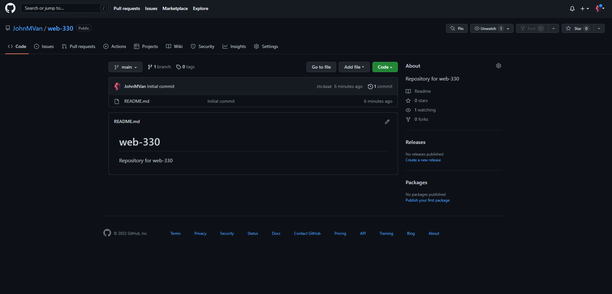

Screen shot of local directory

